Task : 1
Aim :
To Access and print the element at a given index in an array using java.
Algorithms :
Start
- Input the array (list of elements).
- Input the index (position of the element you want to access).
- Check validity of index:
If index < 0 OR index >= array length → print "Invalid index".
Else → continue.
- Access the element at the given index.
- Print the element.
- End.

Program :
public class AccessArrayElement {
public static void main(String[] args) {
int[] numbers = {10, 20, 30, 40, 50};
int index = 2;
if (index >= 0 && index < numbers.length) {
System.out.println("Element at index " + index + " is: " + numbers[index]);
} else {
System.out.println("Invalid index! Please choose between 0 and " + (numbers.length - 1));
}
}
}

Out put :

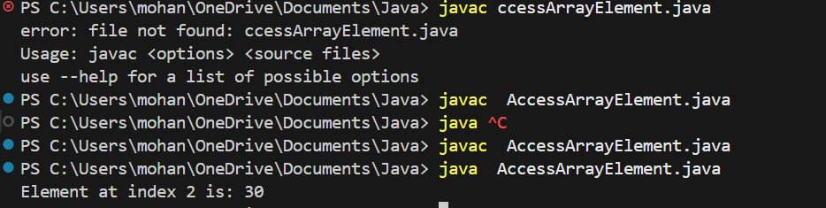

Result :

Thus the implementation of Access and print the element at a given index in an array using java was executed successfully.

Task : 2
Aim :
To Search for a given element in a sorted array using Binary Search.
Algorithms :
- Start
- Input: a sorted array A and the element key to search
- Initialize low = 0 and high = n - 1 (where n is the array size)
- Repeat while low <= high:
  - Calculate mid = (low + high) / 2
  - If A[mid] == key → return mid (element found)
  - Else if A[mid] < key → set low = mid + 1 (search right half)
  - Else → set high = mid - 1 (search left half)
- If loop ends without finding → return -1 (element not found)
- End.

Program :
public class BinarySearchShort {
public BinarySearchShort() {
}
public static int binarySearch(int[] var0, int var1) {
int var2 = 0;
int var3 = var0.length - 1;
while(var2 <= var3) {
int var4 = (var2 + var3) / 2;
if (var0[var4] == var1) {
return var4;
}

if (var0[var4] < var1) {
var2 = var4 + 1;
} else {
var3 = var4 - 1;
}
}
return -1;
}
public static void main(String[] var0) {
int[] var1 = new int[]{10, 20, 30, 40, 50};
byte var2 = 40;
int var3 = binarySearch(var1, var2);
System.out.println(var3 != -1 ? "Found at index " + var3 : "Not found");
}
}

Output :

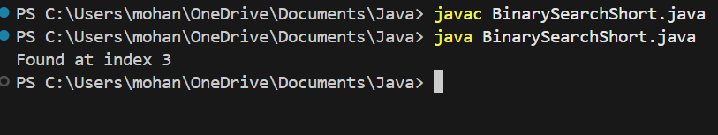

Result :
Thus the implementation of Search for a given element in a sorted array using Binary Search was executed successfully.

Task 3:

Aim :
To Find the maximum element in an array of n integers using java.
Algorithm :
- Start
- Input: an array A of size n
- Initialize: set max = A[0] (first element as the current maximum)
- Repeat for each element from index 1 to n-1:
  - If A[i] > max → update max = A[i]
- After loop ends, max holds the largest element in the array
- Output: print max
- End.

Program :
public class MaxElementInArray{
public static void main(String[]args){
int[]arr={12,45,67,23,89,34};
int n=arr.length;
int max=arr[0];
for(int i=1;i<n;i++){
if (arr[i]>max){
max = arr[i];
}
}
System.out.println("Maximum element in the array is:"+max);
}

Output :
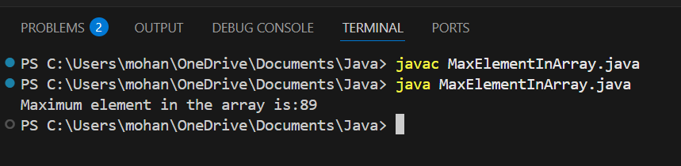

Result :
Thus the implementation Find the maximum element in an array of n integers using java was executed successfully.

Task 4 :

Aim :
To Given an array of integers and a positive integer K, write a program to find:The Kth smallest element using java.
Algorithm :
- Start
- Input:
  - An array A of size n
  - A positive integer K (where 1 ≤ K ≤ n)
- Sort the array A in ascending order
- Access the element at position K-1 (since arrays are usually 0-indexed)
- Output: print the element as the Kth smallest
- End.

Program :
import java.util.Arrays;
public class KthSmallestElement{
public static void main(String[]args){
int[] arr={12,3,5,7,19};
int k = 2;
Arrays.sort(arr);
int KthSmallest = arr[k - 1];
System.out.println("The"+ k +"th smallest element is :"+ KthSmallest);
}
}

Output :
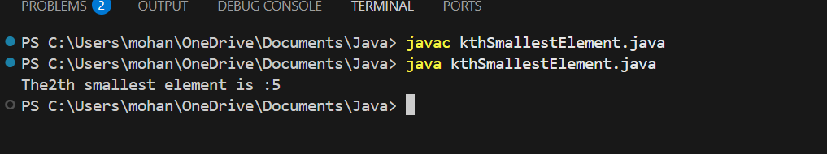

Result :
Thus the implementation of Given an array of integers and a positive integer K, write a program to find:The Kth smallest element using java was executed successfully.

Task 5 :

Aim :
To Print all possible pairs of elements from an array of size n using java.
Algorithm :
- Start
- Input: an array A of size n
- Repeat for each element A[i] from index 0 to n-1:
  - For each element A[j] from index i+1 to n-1:
  - Print the pair (A[i], A[j])
- End.
Program :
public class cv {
public static void main(String[] args) {
int[] arr = {1, 2, 3, 4}; // Example array
int n = arr.length;
for (int i = 0; i < n; i++) {
for (int j = i + 1; j < n; j++) {
System.out.println("(" + arr[i] + ", " + arr[j] + ")");
}
}
}
}

Output :
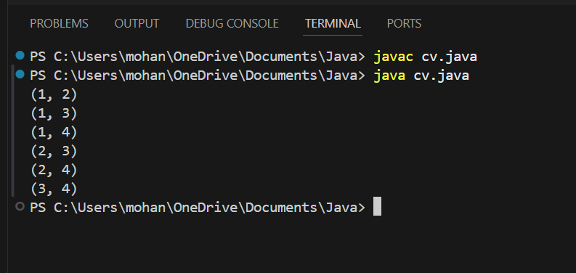

Result :
Thus the implementation Print all possible pairs of elements from an array of size n using java was executed successfully.

Task 6 :
Aim :
To perform the program that calculates the sum of digits of a given integer, with an option to compute either the sum of even digits or the sum of odd digits based on user choice.
Algorithm :
- Start
- Input:
  - An integer num
  - An option opt (either "even" or "odd")
- Initialize: sum = 0
- Set a temporary variable temp = num
- Repeat while temp > 0:
  - Extract the last digit → digit = temp % 10
  - If opt = "even" and digit % 2 == 0 → add digit to sum
  - Else if opt = "odd" and digit % 2 != 0 → add digit to sum
  - Remove the last digit → temp = temp / 10
- After loop ends, sum contains the required digit sum
- Output: print "Sum of even/odd digits = sum"
- End

Program :
import java.util.Scanner;
public class DigitSumOption {
public static void main(String[] args) {
Scanner sc = new Scanner(System.in);
System.out.print("Enter an integer: ");
int num = sc.nextInt();
System.out.print("Enter option (even/odd): ");
String opt = sc.next().toLowerCase();
int sum = 0;
int temp = num;
while (temp > 0) {
int digit = temp % 10;
if (opt.equals("even") && digit % 2 == 0) {
sum += digit;
} else if (opt.equals("odd") && digit % 2 != 0) {
sum += digit;
}
temp /= 10;
}
System.out.println("Sum of " + opt + " digits = " + sum);
sc.close();
}
}

Output :
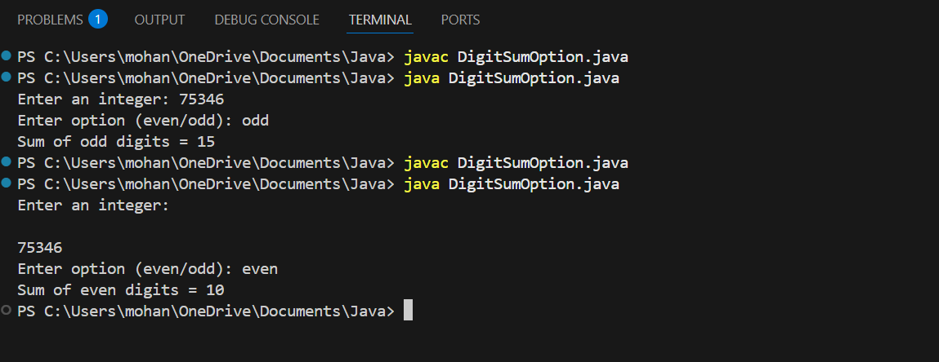

Result :
Thus the implementation calculates the sum of digits of a given integer, with an option to compute either the sum of even digits or the sum of odd digits based on user choice was executed successfully.

Task 7:
Aim :
To implement the Nth Fibonacci using java.
Algorithm :
- Start
- Input: an integer n (the position of the Fibonacci number to find)
- Check base cases:
  - If n == 1 → return 0
  - If n == 2 → return 1
- Initialize variables:
  - a = 0 (first Fibonacci number)
  - b = 1 (second Fibonacci number)
  - c = 0 (temporary variable for next Fibonacci number)
- Repeat from i = 3 to n:
  - Compute c = a + b
  - Update a = b
  - Update b = c
- After loop ends, b holds the Nth Fibonacci number
- Return b
- END.

Program :

public class UserMainCode {
public static long nthFibonacci(int input1) {
if(input1 == 1) return 0;
if(input1 == 2) return 1;
long a = 0, b = 1, c = 0;
for(int i = 3; i <= input1; i++) {
c = a + b;
a = b;
b = c;
}
return b;
}
public static void main(String[] args) {
int n = 1;
System.out.println(nthFibonacci(n));
}
}

Output :
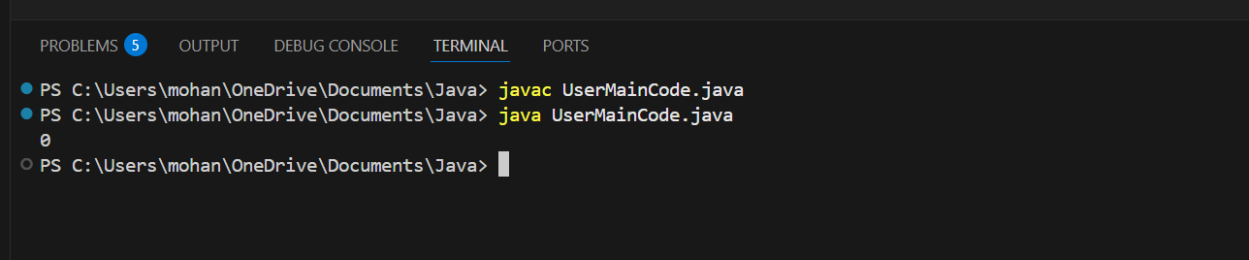

Result :
Thus the implementation Nth Fibonacci using java was executed successfully.

Task 8 :
Aim :
To implement the isPalindrome Number using java.
Algorithm :
- Start
- Input: an integer n
- Store original number → original = n
- Initialize → reverse = 0
- Repeat while n > 0:
  - Extract last digit → digit = n % 10
  - Update reverse → reverse = reverse * 10 + digit
  - Remove last digit → n = n / 10
- After loop ends:
  - If original == reverse → return 2 (number is palindrome)
  - Else → return 1 (number is not palindrome)
- Output: print result
- End.

Program :
import java.util.*;
class UserMainCode
{
public int isPalinNum(int input1){
int original = input1;
int reverse = 0;
while (input1 > 0) {
int digit = input1 % 10;
reverse = reverse * 10 + digit;
input1 = input1 / 10;
}
if (original == reverse)
return 2;
else
return 1;
}
public static void main(String[] args) {
Scanner sc = new Scanner(System.in);
int n = sc.nextInt();

UserMainCode obj = new UserMainCode();
int result = obj.isPalinNum(n);
System.out.println(result);
}
}

Output :
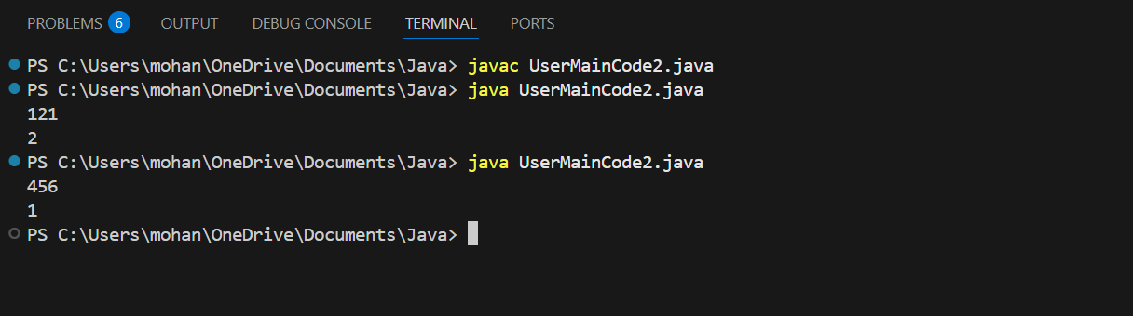

Result :
Thus the implementation isPalindrome Number using java was executed successfully.

Task 9 :
Aim :
To implement Sum of last digit of two given numbers using java .
Algorithm :
- Start
- Read two integers input1 and input2
- If input1 is negative, convert it to positive
- If input2 is negative, convert it to positive
- Find the last digit of input1 using input1 % 10
- Find the last digit of input2 using input2 % 10
- Add both last digits
- Return the sum
- Stop

Program :
import java.util.*;
class UserMainCode
{
public int addLastDigits(int input1, int input2){
if(input1 < 0){
input1 = -input1;
}
if(input2 < 0){
input2 = -input2;
}
int lastdigit1 = input1 % 10;
int lastdigit2 = input2 % 10;
return lastdigit1 + lastdigit2;
}

public static void main(String[] args){
Scanner sc = new Scanner(System.in);
int a = sc.nextInt();
int b = sc.nextInt();
UserMainCode obj = new UserMainCode();
System.out.println(obj.addLastDigits(a, b));
}
}

Output :

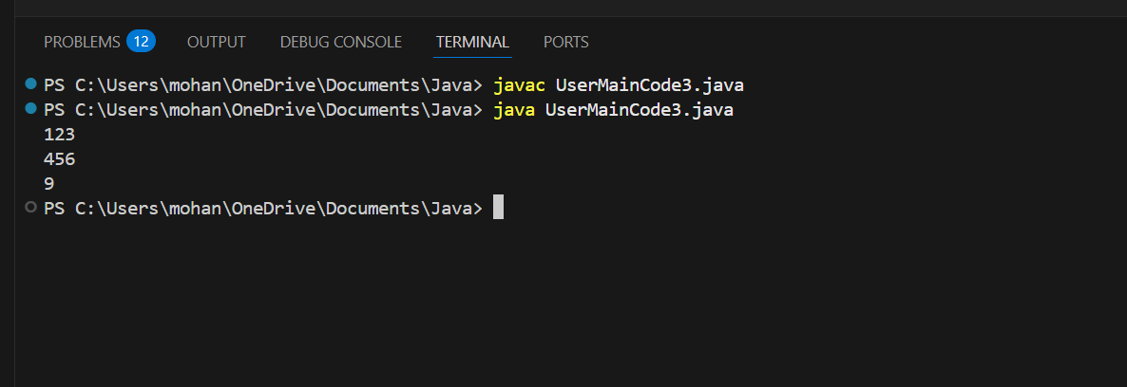

Result :
Thus the implementation Sum of last digit of two given numbers using java was executed successfully.

